**Blog Article API-Documentation**

Creating blog table:

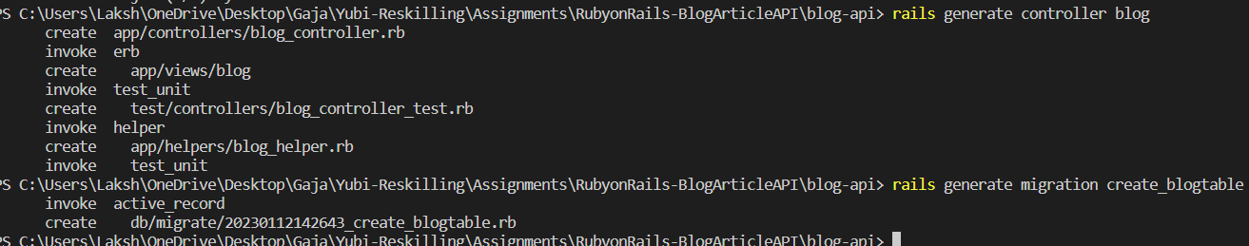

Running db:migrate after table creation:

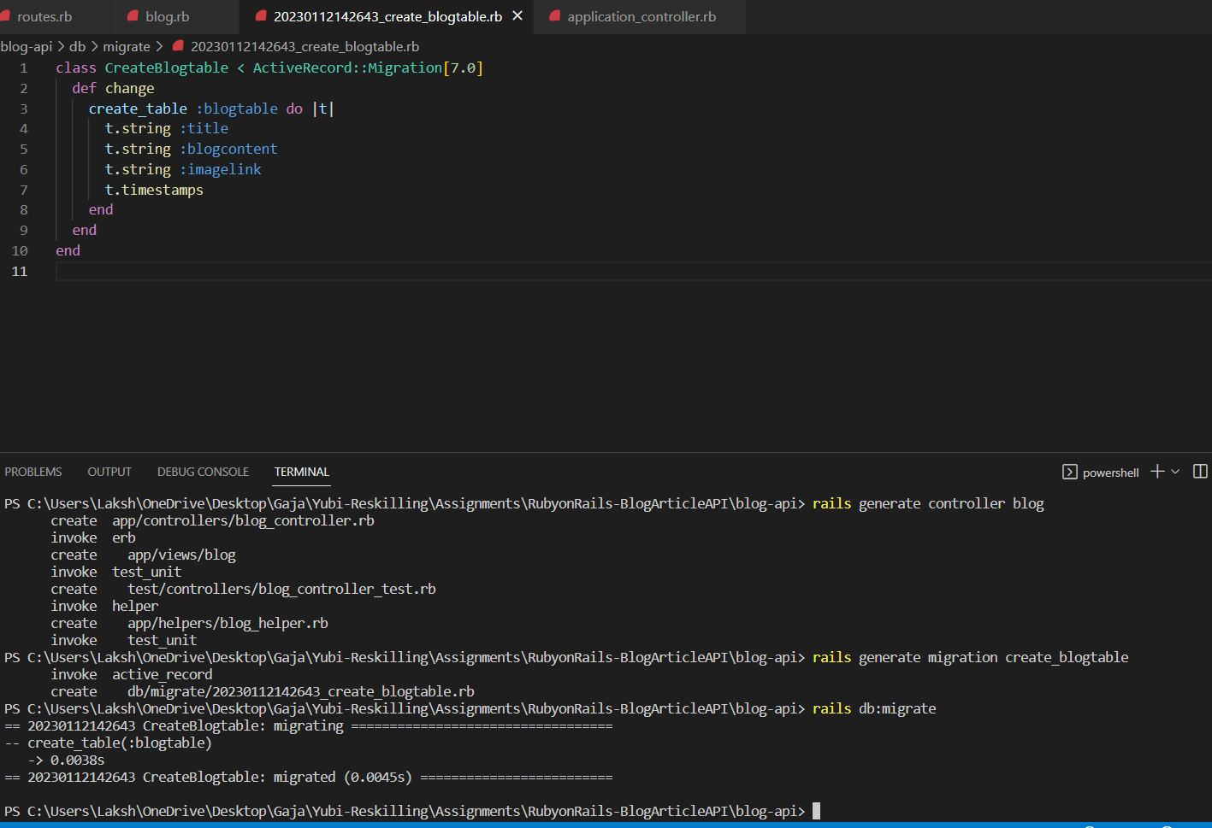

Adding blogapis table row/record by creating new instance : b =Blogapi.new

b.title = “Mashable”

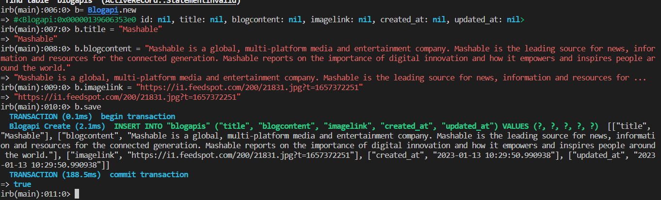

Adding blogapis table row/record using create method directly:

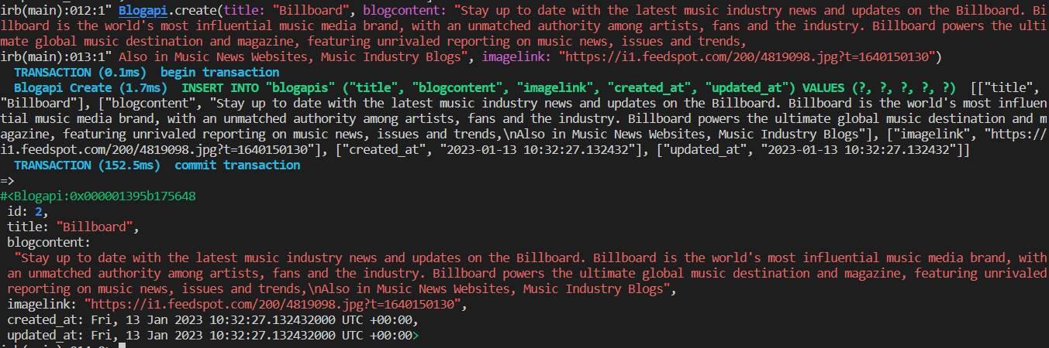

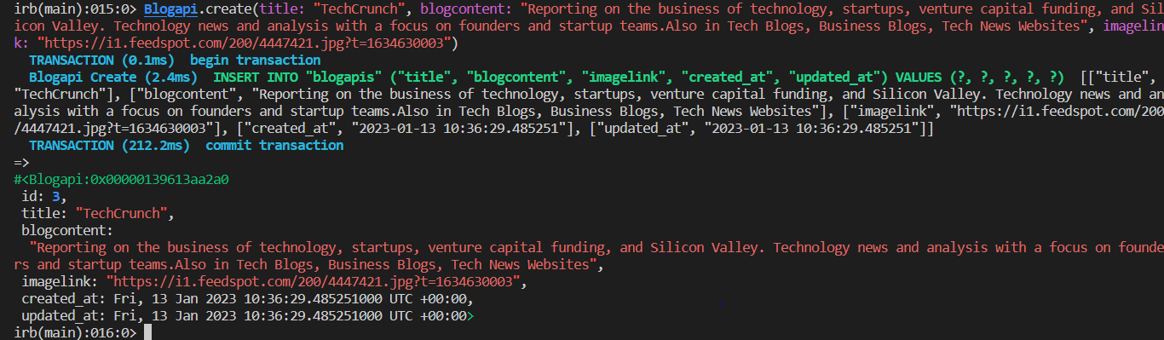

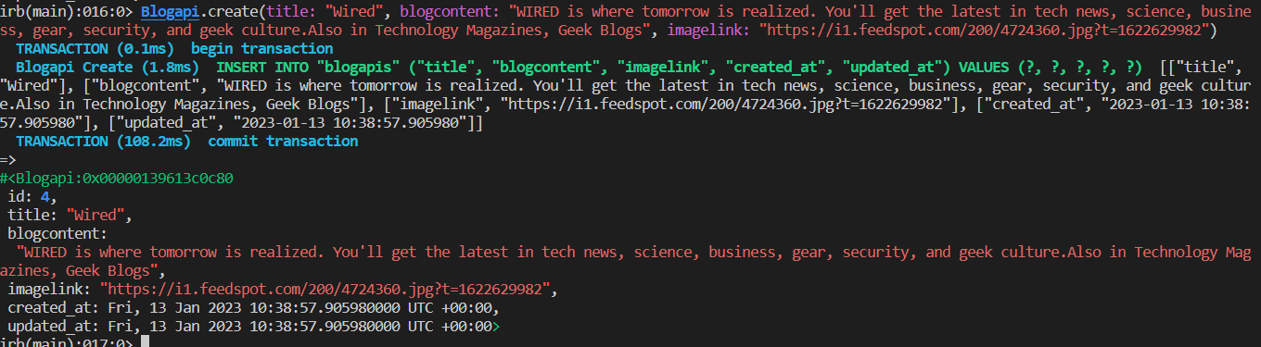

Updating a record by getting the instance at id =1 and changing the title

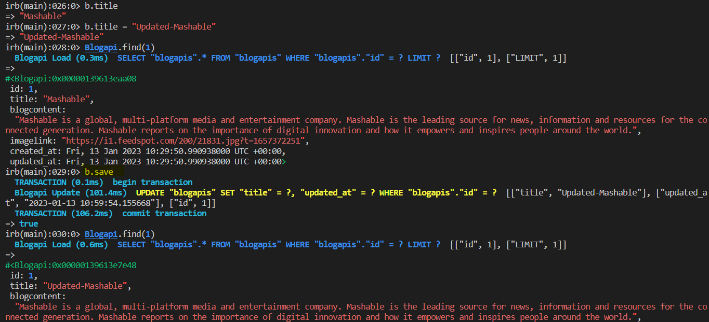

Updating using update_attribute

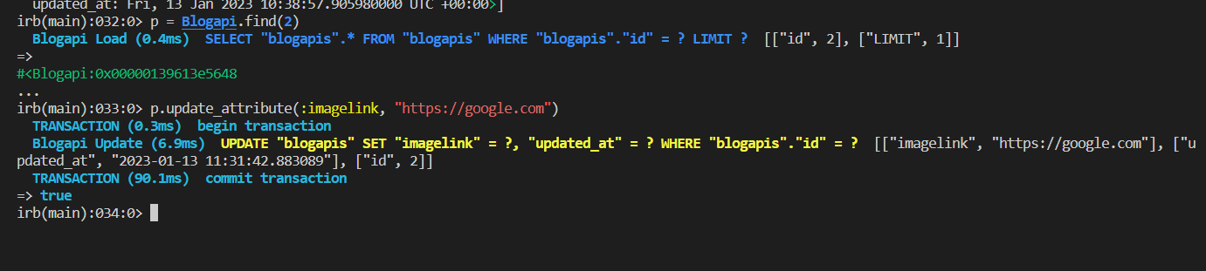

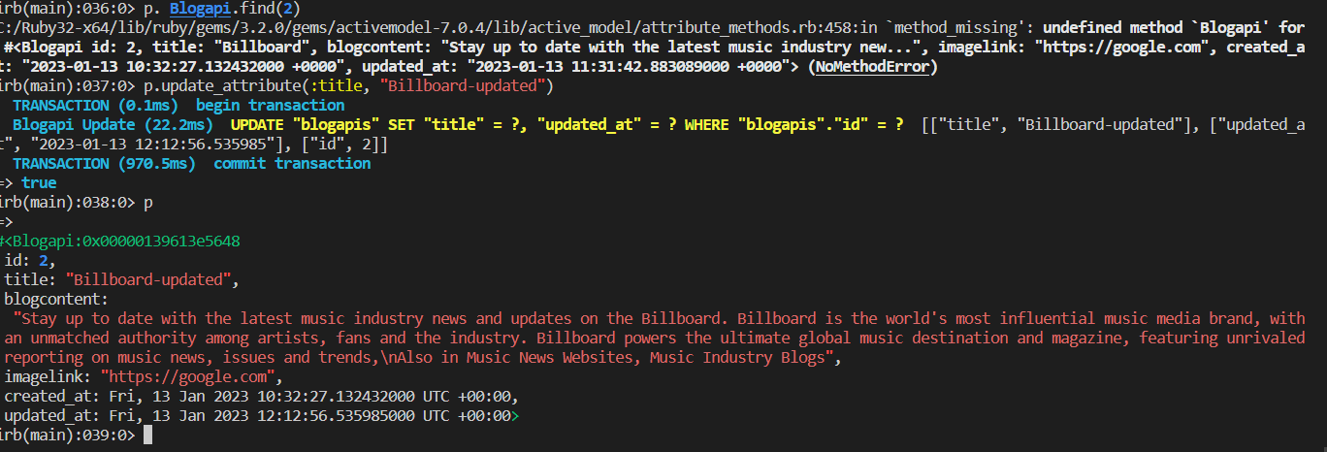

Updating record using update function

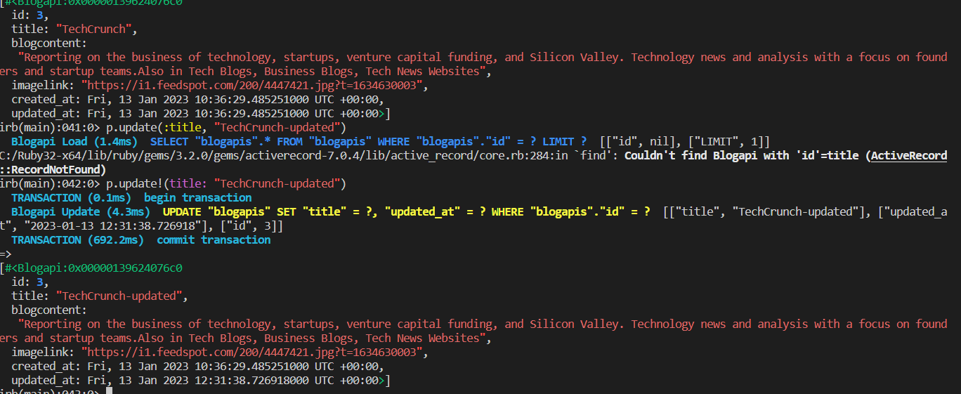

Deleting the record using destroy:

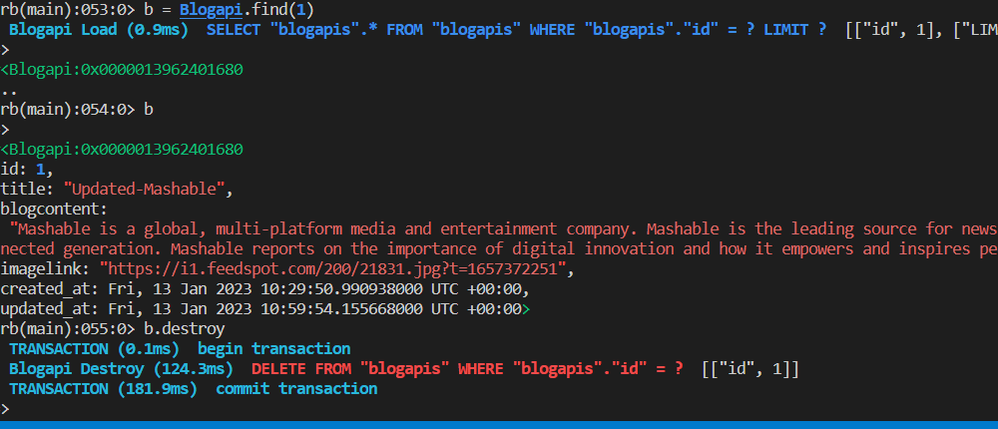

Fetch the api data in json format using postman:

